PRESS RELEASE FOR IMMEDIATE RELEASE

NELSON PIQUET JR. TO PASS SH RALLYCROSS TORCH TO ANDREAS BAKKERUD FOR X GAMES

(CHARLOTTE, NC) May 28, 2015 - SH Rallycross announced today that Nelson Piquet Jr. will pass the No. 07 HYDROXYCUT – SH Racing Ford Fiesta ST machine to Andreas Bakkerud for the 2015 Austin X GAMES, June 6 at Circuit of the Americas in Austin, Texas.

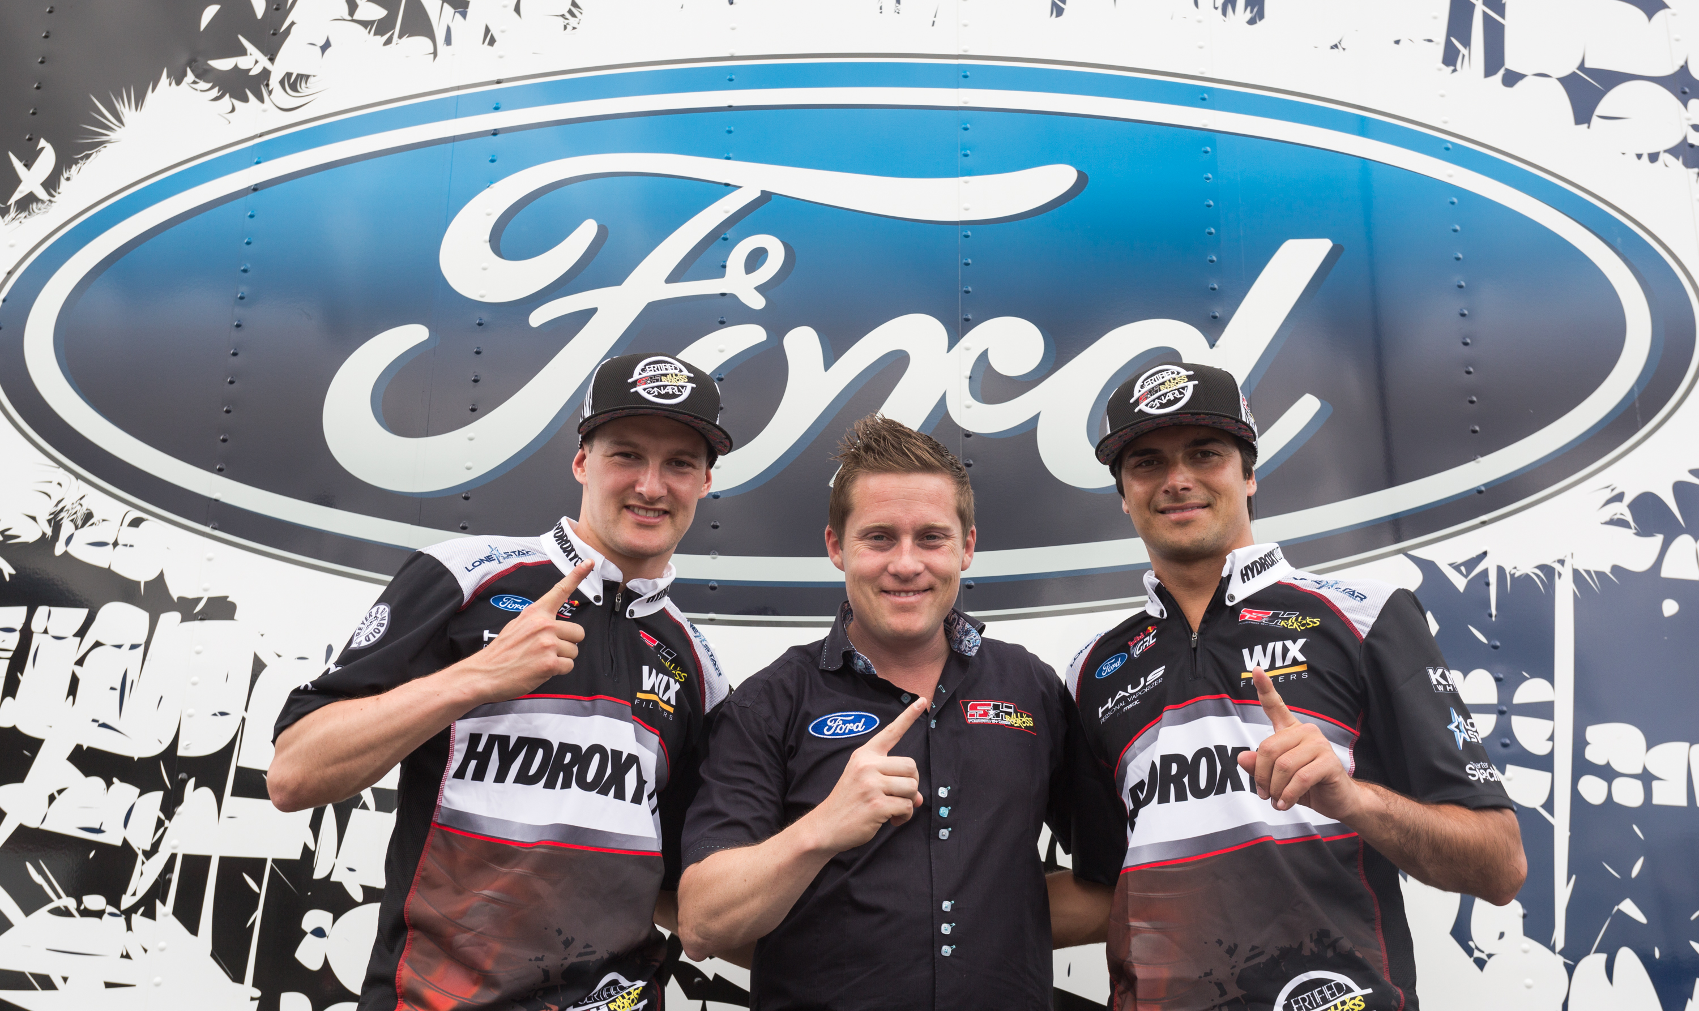

The move was made because Piquet Jr., who earned a Bronze medal at the 2014 Summer X GAMES, is currently leading, but in a four-way battle for the Formula E crown with just three races remaining in the championship. The one-race hiatus will allow Piquet Jr. to compete in the Formula E event in Moscow, Russia.

“We've got an opportunity here to get behind Nelson and help give him the chance to do something special in going after the inaugural Formula E championship,” said James “Sulli” Sullivan, Principal SH Rallycross. “This won't affect us in the Red Bull Global Rallycross championship standings so that's what we're going to do.”

Sulli went on to say, “The decision to bring in Bakkerud was a no brainer for us. He's one of the few drivers that knows the new 2015 spec car SH Rallycross is running like the back of his hand and he's sitting third in the WRX championship. “

Bakkerud, 24 from Bergen, Norway, is one of the top and most experienced Rallycross drivers in the world. He has won the FIA European Rallycross Championship in the Super 1600 category twice (2011 and 2012) and currently competes in the FIA World Rallycross Championship Super Car category where he is third in the championship standings after the first four races.

“I have been in Rallycross my whole career,” said Bakkerud. “This is a big opportunity for me and I am very excited. I know Sulli and the team from spotting for Nelson in Barbados and the X GAMES last year and I am proud to be able to compete with SH Rallycross and am honored to be able to step in for Nelson at the X GAMES.”

Piquet Jr. said, “Rallycross has been in my heart since I've drove it for the first time. It’s been a little more than a year since I joined SH Rallycross and we continue to get stronger. A few months ago I took another challenge, competing in Formula E and right now we have a chance to win the championship. Therefore, I'm not going to be able to take part in the wonderful event, the X GAMES! I'll be in Moscow thinking about those amazing jumps and all those battles, but I'll also be trying to win the first ever Formula E championship. Good luck to my boys and I'll be back for Daytona even stronger.”

SH Rallycross had a break-out first season contending for the RedBull Global Rallycross Championship in its first year in the series with four consecutive podiums including the Bronze at the Summer X GAMES with Piquet Jr. behind the wheel. The team expects to make additional major sponsorship announcements including another Primary sponsor in the coming days.

About HYDROXYCUT:
Hydroxycut is the No. 1 selling weight loss supplement brand in America. For over 20 years, Hydroxycut has helped countless individuals across the globe reach their weight loss goals. Today, its industry-leading focus on research and innovation continues to lead to new, effective ways to lose weight with products such as Pro Clinical Hydroxycut, Hydroxycut Hardcore, and Hydroxycut Hardcore Next Gen! For more information about Hydroxycut visit www.hydroxycut.com or www.muscletech.com.

About SH Rallycross and Nelson Piquet Jr.:
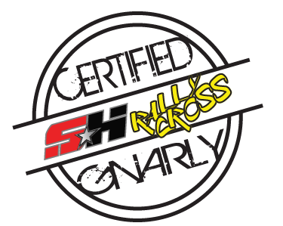
Led by Team Owner James “Sulli” Sullivan and Dennis Reinbold, SH Rallycross fields a factory Ford Fiesta in the Red Bull Global Rallycross with Formula 1 and NASCAR veteran Nelson Piquet Jr. as driver. SH Racing also competes in the Verizon IndyCar Series as a partner in KVSH Racing with full season driver Sebastien Bourdais.

Piquet Jr., who quickly adapted to Rallycross with SH in 2014, spent four years working his way up the NASCAR ranks. During his NASCAR career, Piquet Jr. became the first Brazilian to visit Victory Lane in the Nationwide Series by taking the checkered flag at Road America in 2012. He is best known for his time in Formula 1 with the ING Renault team, starting as a test driver and graduating to a full-time ride. He also won the Formula E event in Long Beach.

About Red Bull Global Rallycross:
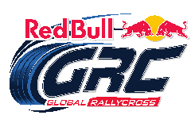
Designed to produce the fastest and most exciting racing in motorsports, Red Bull Global Rallycross pits small production-based cars against each other in door-to-door racing featuring dirt, asphalt, and table-top jumps. With enhanced engineering and safety features, the cars produce 600 horsepower and can accelerate from 0-60 miles per hour in less than two seconds, and can also withstand 70-foot jumps and other vehicle contact. For more information visit www.RedBullGlobalRallycross.com.

###
SH Rallycross
Matt Magnino
Media Contact
(630) 457-8710
Magnino@teamshracing.com

